

**Call Logger v0.1.3 Instruction Manual**

Hello! If you’re reading this, I am dead. Or you want to log calls conveniently in a .csv file using a handy-dandy “Date | SR# | Time | Phone#“ format. Either way, this should help!

**Setup**:

There is no setup! All you have to do is double-click the “CallLogger.exe” to run!

It is important that the CallLogger.exe file remain within the main CallLogger folder alongside the “Call Logs,” “Resources,” and “Settings” folders in order to operate optimally.

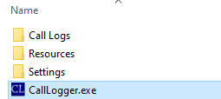

It is recommended that the Call Logger folder containing the application and sub-folders be placed in a directory like “Documents,” and then right-clicking the executable to create a shortcut which can be moved around as needed!

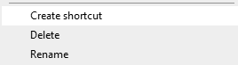

**Use:**

Copy the case number the call was related to into the “SR” box, and copy raw notes from whatever note-taking tool you use into the “Raw Notes” box. Afterwards hit the Parse n Add button to add them to the current Calllog.csv (noted by the top box). It will automatically use the date from the “Date” box, which can be shifted or reset as needed.

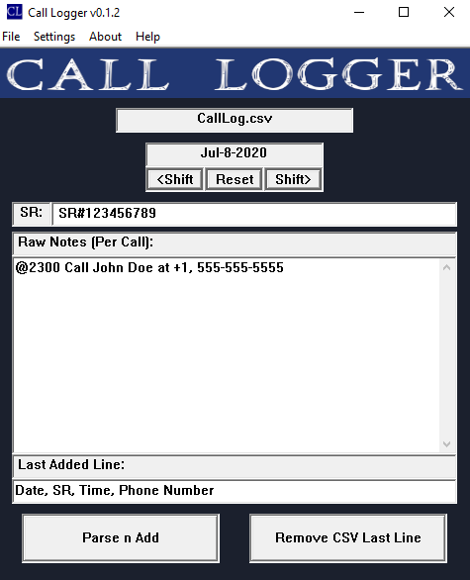

Once it has successfully added the note to the Call Log, it will display in the “Last Added Line” box. If something is wrong with the note submitted, hit the “Remove CSV Last Line” button to remove the last line.

It should be noted that **only one call can be parsed at a time**, but that if multiple calls are made for the same case, only the raw notes need to be updated.

Additionally, the notes can be as complex as needed, with up to 1,000 characters and in any format.

The only formatting issue is that the **Call Time must always be before the Phone Number.**

**Settings:**

The “Settings” window lets your enable Weekly Auto-Splitting, Monthly Splitting, and setting your workdays. While this is disabled, all calls are logged in a single CallLog.csv file. While it is enabled, it will automatically create new .csv files for the current date, and using your workdays.

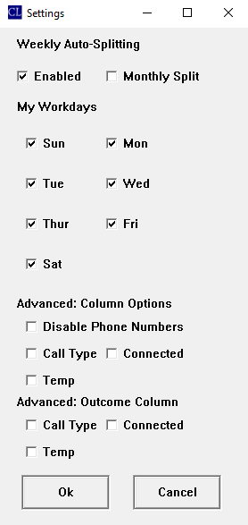

As an example, if you work Monday through Friday, and the date is July 8th of 2020, the .csv will be “CallLog Jul 5 to Jul 11.csv”

*While Weekly Auto-Splitting is enabled*, you can also enable a “Monthly Split” to automatically create a .csv file for the month. With Monthly Split enabled, workdays are not taken into account, so with the previous example it would be “CallLog Jul 1 to Jul 31.csv”

**An important note**: Shifting the date box on the Main Window while Auto-Splitting is enabled changes the current .csv file CallLogger is accessing. In this way, if you go back or forward a week, it will create or access that week’s .csv file. If Monthly Split is also active, and the date pushed far enough to be in another month, CallLogger will create or access that month’s .csv file.

**Advanced: Column Options**

Disable Phone Numbers removes the “Phone Number” column normally added to the .csv file.

The “Call Type” option adds a “Call Type” column which will notate the call as an Intro, Triage, Closure, or Miscellaneous based off keywords located in the raw notes.

The “Connected” option adds a “Connected(Y/N)” column which will attempt to notate the call as Answered, No Answer, No Answer-VM, and No Answer-No VM based off keywords located in the raw notes. It initially assumes a call was Answered, but then checks for common phrases such as “voicemail” or “no answer” to identify that the call was not answered. If it was not answered, it will then check keywords revolving around “voicemail” to determine if a voicemail was left.

The “Temp” option adds a “Temp” column which will attempt to notate the customer’s temperature as Cool, Warm, or Hot based off keywords located in the raw notes. It initially assumes the customer is Cool, but then checks to verify if the customer is Hot, and then if they are Warm.

**Advanced: Outcome Column**

The Outcome Column options have the exact same function as their column option counterparts; however, all of the outputs are relegated to a single “Outcome” column.

**File Menu:**

The File Menu provides a few easy access options.

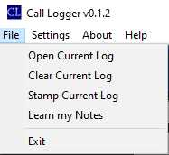

The Open and Clear Current Log buttons do exactly what they say, Opening or Clearing the current log. It should be noted that, if Auto-Splitting is enabled, the Main Window’s date box will determine which log is currently being accessed (see the “An Important Note” section above for further details).

The “Stamp Current Log” adds a “Stamp” providing the number of “Total Cases” and “Total Calls” present in the .csv at the time of stamping. This is always added to the last row, and serves to make determinations of “average calls per case” easier. Stamps will not count other stamps, which can also make them a convenient way of tracking the fluctuation of that average over time.

That said, **stamps are recommended to only be used at the end of a Call Log, before submission**, to keep log data clean!

The Learn my Notes feature is currently inactive. Due to hardware limitations and security restrictions, AI features which would allow the parser to learn a particular note-taking style are not available.

Exit closes the program, and is where this tutorial ends!

Have fun Logging Calls!